**4. Results Analysis and Discussion**

The problem statement, goal, current state, and stakeholders have been identified in the define phase of the Six Sigma DMAIC approach. In the measure phase, various tools were used to measure and assess the current situation of the Libyan Airline processes at Benina airport. In addition, data collection plan has been constructed to collect relevant data. The collected data will be analyzed in the analyze phase using statistical methods to determine the root causes of the problem.

**4.1 Analyze Phase**

The main goal of the analyze phase of the Six Sigma DMAIC is to identify the potential root causes of the problem being investigated using given data and information. Such analysis includes cause-effect and statistical analyses such as control charts, Pareto charts, etc. After completing the measure phase, the team performed comprehensive analysis on the delay in departure (problem statement) and summarized the findings in the following sections.

**4.1.1 Root Cause Analysis**

Several factors contribute to the delay of departure of Libyan Airlines’ flights at Benina Airport. These factors have been classified using a Cause-and-Effect diagram, which is also known as Fishbone diagram. The causes have classified into six categories namely: Man; Method; Management; Machine; Material; and Environment. In the Man section, lack of strong training for suppliers and employees is one of the direct causes of delay in departure. Based on interviews with Libyan Airlines’ staff, suppliers at Benina airport lack strong working efficiency in delivering their services to Libyan Airlines. Sometimes they carry their services in an efficient way with no value to the speed of services, which most of the time leads to delay. One of the causes in the Method section is the lack of coordination between suppliers and Libyan Airlines. For instance, there has always been lack of coordination between Libyan Airlines and Al-Sama Co., regarding the number of meals that Sama delivers on each trip as the number of booked seats changes every time with no prior notice.

Lack of process improvement initiative by the management of the Libya Airlines is another factor contributing to the delay in departure. Adoption of process improvement methods such as Six Sigma can significantly help the company reduce the delay and improve customer satisfaction. Other causes of the delay are illustrated in figure 4.1.

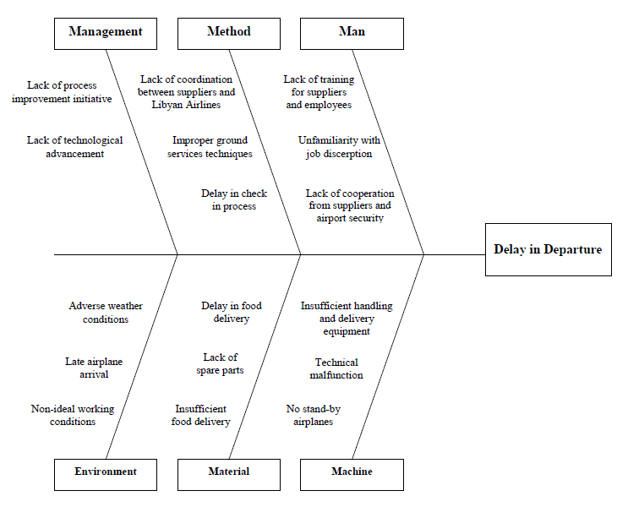

**Fig. 4.1** Fishbone diagram of delay in departure

**4.1.2 Statistical Analysis**

Based on the annual report of flight movement at Benina airport, there is a total of 3771 flights that Libyan Airlines operated in 2013, 1838 of those flights were late in departure (shown in table 4.1 below), 846 flights departed earlier than its scheduled time, and 1087 flights departure on-time.

**Table 4.1** Total number of flights of Libyan Airlines in 2013

|  |  |
| --- | --- |
| **Status** | **No. of Flights** |
| On-time Departure | 1087 |
| Early Departure | 846 |
| Late Departure | 1838 |
| Total | 3771 |

The data can also be visualized using a pie chart as shown in figure 4.2. It can be clearly realized that almost 50% of all flights in 2013 have been late in departure. This indicates that there is too much variation in the processes of Libyan Airlines at Benina airport that led to such a great figure.



**Fig. 4.2** Total flight movement of Libyan Airlines in 2013

Table 4.2 summarizes the various causes of the delay in departure based on software called Daily Movement Monitor that the company uses to track the daily movement of its fleet on a daily basis. The table includes environmental causes such as the weather, causes traceable to suppliers, and causes rooted to Libyan airlines’ staff.

**Table 4.2** Causes of delay in departure of Libya Airlines

|  |  |
| --- | --- |
| **Cause** | **Frequency** |
| Weather | 33 |
| Catering | 246 |
| Fuel | 112 |
| Ground Services | 222 |
| Airport Security | 162 |
| Aircrew | 229 |
| Technical Malfunction | 40 |
| Ground Engineer | 24 |
| Late Arrival | 563 |
| Others | 207 |

To easily visualize the causes of the delay and identify the factors that contribute most to the delay, the team constructed a Pareto diagram as shown in figure 4.3. The advantage of using the Pareto diagram is that it shows the causes or defects in a descending order so that the cause with the highest frequency is given most of the consideration. It can be seen that “late airplane arrival” is the cause with the highest frequency, which contributes about 31% of the total delay. In fact, “late airplane arrival” is a result of the other causes listed in the table 4.2 such as catering, fuel, and ground services. Therefore, Catering is considered as the cause with highest frequency with 13.4% of the total delay. Catering is provided to Libyan Airlines by Al-Sama Co.

Since all suppliers of the Libyan Airlines are owned by the government, the Libyan Airlines has no eligibility to fire a supplier or break a contract for whatever reason. This issue itself contributes to the delay as suppliers are aware of this fact and sometimes take advantages of it.

After catering, aircrew is ranked as the second cause of delay in terms of frequency of occurrence. Aircrew contributes to more than 12% of the total delay in 2013. It should be noted that Libyan Airlines underestimate this fact. Indeed, when the Six Sigma team conducted interviews and focus groups with Libyan Airlines to identify the root causes of the delay, the company believed that most of the delay was caused by the suppliers such as ground service providers, and that they had nothing to do to fix this problem.



**Fig. 4.3** Pareto diagram of causes of delay

In addition, the report shows that there are 207 flights of the total 2337 flights with unknown delay causes contributing to more than 11% of the total delay. Thus, an investigation should be made by Libyan Airlines to determine the causes of delay of these flights as this number cannot be neglected.

The causes of the delay can be viewed in a different way as shown in figure 4.4. The causes were classified to categories such as suppliers and Libyan Airlines. Suppliers include catering, fuel, ground services, and airport security, and they contribute to nearly 40% of the total delay. Libyan Airlines, on the other hand, includes aircrew and ground engineers, and they contribute to more than 13% of the total delay.



**Fig. 4.4** Pie chart of delay causes after reclassification

**4.2 Improve Phase**

The pure objective of Six Sigma is to increase the improvement factors that can help achieve a perfect level of performance. Focusing on characteristics that are very critical to customers and identifying, reducing, or eliminating causes of errors that may have an effect on the performance of processes or quality of products is the main purpose of this phase. After analyzing the root causes of problem in the previous phase, the team will work on finding the best solution for these problems. How to eliminate the root causes of problems is a common question in the improve phase. In some cases, redesigning organization culture or reengineering technical systems may be required in order to eliminate these causes.

In this phase, the team will suggest an improved process map as part of the solution. This map will, if implemented, facilitate operations in the airport and streamline the entire process, which will result in significant decline in the delay. Furthermore, the team will provide a list of recommendations that the company should consider to improve performance and increase customer satisfaction.

**4.2.1 Improved Process Map**

In this section, the team will propose a new process map based on the findings from the analyze phase. The improved process map includes all important processes that are required to reduce the existing variability and exclude all Non Value Added (NVA) processes. Figure 4.5 shows the detailed process map presented in the measure phase with identification of NVA processes, which is colored with red. As the name suggests, an NVA process may be defined as a process that doesn’t add value to the entire process.

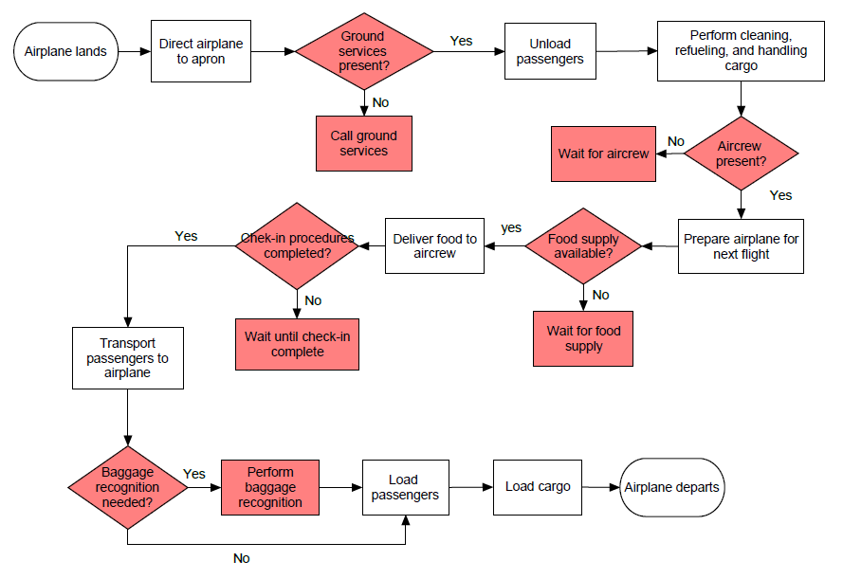

**Fig. 4.5** Detailed process map of landing-departure showing non-value added processes

The team identified five NVA tasks or processes in the detailed process map presented in the measure phase. Each one of these processes means delay, which they then add up to constitute the total delay in departure. After identifying the NVA tasks, the team constructed an improved process map, which provides a solution to most of the problems discussed earlier. To resolve the delay occurred after landing when ground services providers might not be present, the team suggested that a flight dispatcher or a Libyan Airlines representative notify ground services providers with airplane arrival at least few minutes prior landing. Although ground services providers do have knowledge of flight movements on a daily basis, they just ignore the fact that they should be ready upon airplane landing so that they can finish their operations on time.

In addition, the team proposed another task to resolve delay caused by aircrew. According to Libyan airlines’ staff, aircrew should be at the airport at least 90 minutes before departure. By arriving this early, the aircrew can prepare the airplane and make sure that it is ready for next flight. Therefore, the team added the task of transporting the aircrew at least one hour prior departure as this will ensure that the airplane preparation completes on time.

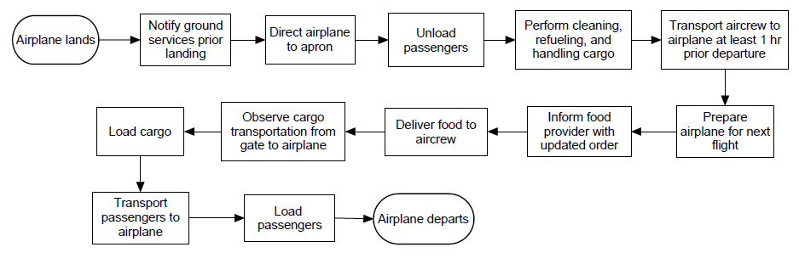

**Fig. 4.6** Improved process map of Libyan Airlines operations at Benina airport

To deal with the delay resulted from food provider, the team suggested two actions. The first action, which is illustrated in figure 4.6, is to inform food provider, Sama co. with updated list of passengers so that the Sama co. delivers extra meals in case the number of passengers admitted to a certain trip has increased. The second action that the team proposed to reduce the delay caused by the food provider is to review the check-in process. In fact, the team found out that the airline agents who perform the check-in process in the airport violate the company’s rules by admitting passengers as late as 45 minutes prior departure. Passengers can buy tickets and get their boarding pass even few minutes before departure if they know one of the airplane agents at the airport. Those passengers cause some delay as their names are not on the flight list, and Sama co. didn’t count them when delivering the meals to the aircrew.

Finally, to resolve the issue of baggage recognition that some pilots request, the team added a task of observing baggage and cargo transportation from the gate where check-in process performed to the airplane. The observation process should also include the loading of cargo to the airplane to assure the pilots that the cargo is secured and ensure that no security violations have been made.

**4.2.2 Recommendations**

Based on the analysis that has been done, the team compiled some recommendations that may be taken into consideration to reduce the delay in departure and improve performance at Benina airport:

1. Reinforce coordination with all parties involved in operations at Benina airport including airport security, airport management, airline agents at check-in area, ground services providers, and so on. Doing so will eliminate obstacles and ensure smooth work procedures.
2. If possible, review contracts with suppliers and enforce new amendments such as applying punishments for those who found responsible for delay in services, and providing incentives for those who perform their tasks efficiently on time for a certain period.
3. Obligate suppliers to acquire plenty of updated handling equipment to avoid delay, especially when more than one airplane is being serviced at the same time.
4. Further investigate the delay caused by aircrew as this delay is easier to resolve comparing to the other causes due to its direct connection with the company and under its control.
5. Replace the manual and primitive check-in process at the airport with a new, computerized technology and train airline agents on using that technology. This action will streamline the process and reduce chance of human error.
6. Obligate airline agents to follow the company’s rules by not admitting passengers who show up at the airport with no previous reservation.
7. Coordinate with Al-Sama Co. on delivering extra meals in case additional passengers have been admitted with no prior notice.
8. Consider assigning at least one stand-by airplane in case un-expected delay such as technical malfunction occurs.
9. Assign greater rule to the quality control department at the company by hiring qualified quality control engineers and train current employees on using quality improvement initiatives such as Six Sigma.

**4.3 Control Phase**

Maintaining improvement is the main goal of this phase. In fact, training employees may be essential to increase their skills to manage and avoid mistakes that can cause errors and increase variation in the improved processes. Moreover, this training can help improve the knowledge of workforces regarding the selected solutions or new culture of work. Within this phase, it is important to ensure that problems that are already solved will not return, and focus on keeping them in good statistical control (controllable processes).

Nevertheless, as this project has not been implemented in real time, the team decided to terminate the project at the improve phase as there is no concrete improvement to control. If, however, Libyan Airlines decided to implement the project in the near future, they should consider working on the control phase to ensure that improvement gained is not lost over time.